Ticket: IM9922607
Doc type: Technical design document
Last refreshed date for Post allocation Dashboard:
Go to Dashboards Post Allocated Expense dashboard→Detail edit dashboard shown below.
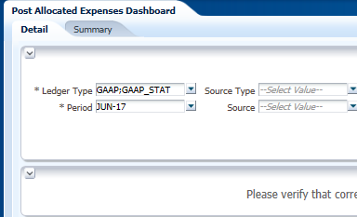
Click on Highlighted button to go to Edit analysis.
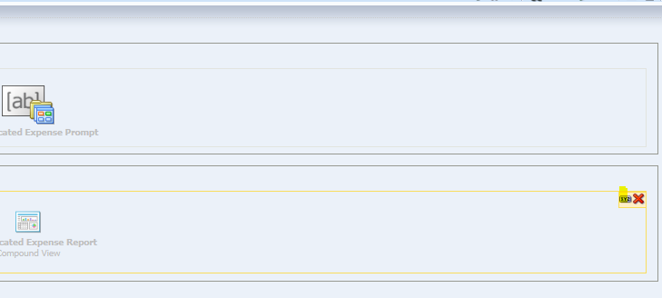
Select Title View as shown below and edit.
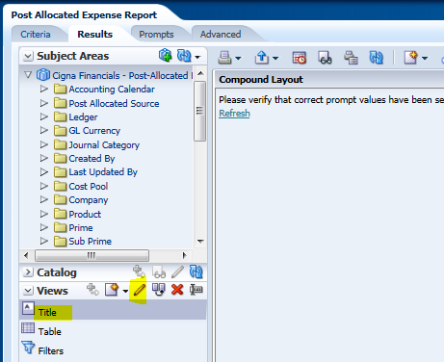

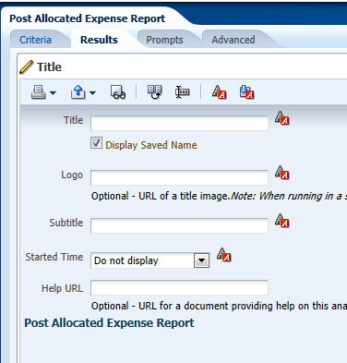
Go to →subtitle→place session variable “WC_POSTALLOC_ETL_LOAD_DATE” as shown blow. And same follow the process for other reports.
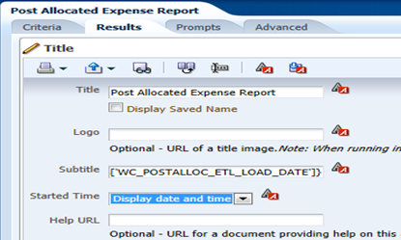
Go to Dashboards Post Allocated Expense dashboard→Summary→ edit dashboard shown below.

Edit Analysis
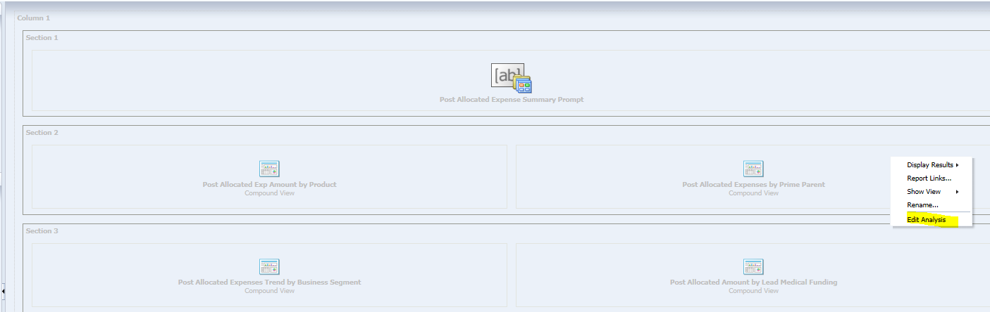
Follow the same steps as shown above:
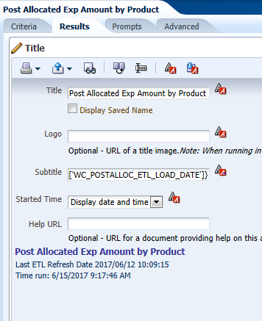
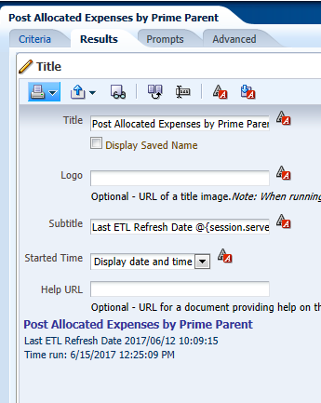

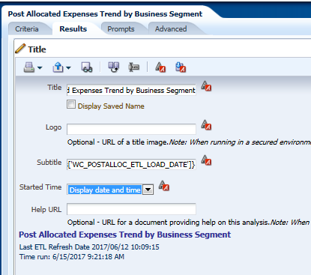
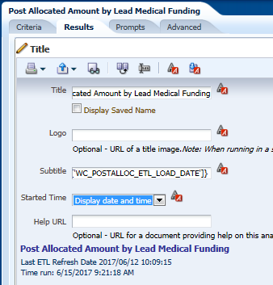
And select Started time as Display date and Time in drop down list.
Save and Exit
Test results:
Go to Dashboard Run Post Allocated Expense dashboard
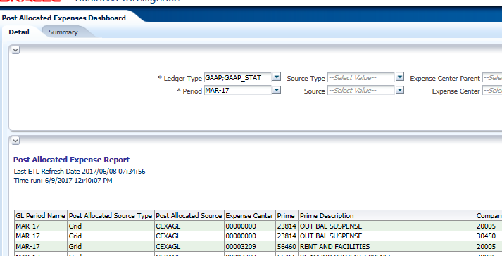
Summary Page:

